- Install the Citrix full version ica32.exe onto the PC. (If re-install, take upgrade/replace option. PC needs be restarted.)

- Start > Programs > Citrix ICA Client > Citrix Program Neighborhood > Add ICA Connection

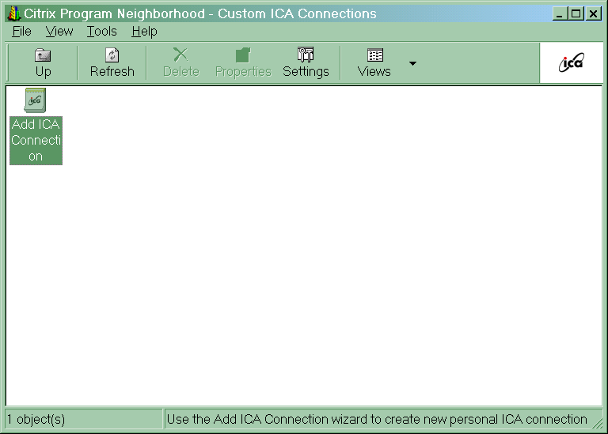

- Customize the connection Properties as shown in screen print below.
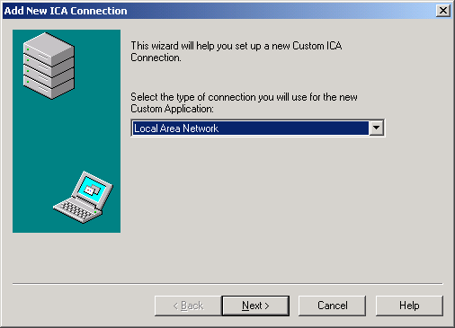

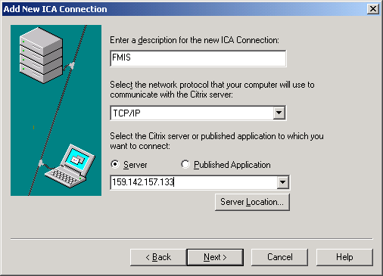

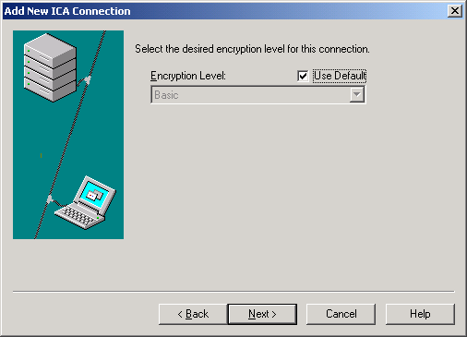

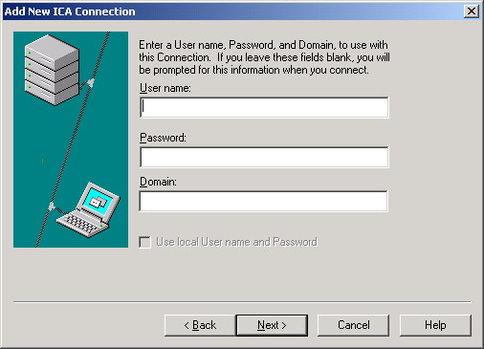

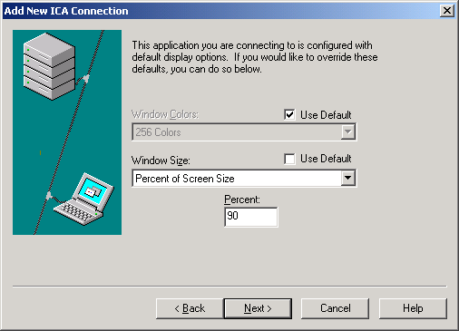

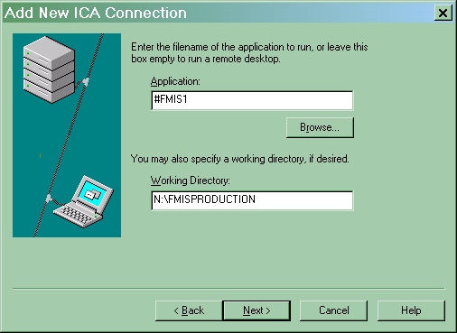

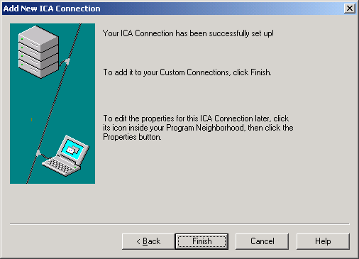

Double click the newly created FMIS icon, and you should get the connection with a prompt to login. Accounting has user name & password. (If not connected, call GSA support. Check to see if: Citrix server IP changed; Citrix new Client needs be downloaded and updated on PC; User’s PC IP changed; .)

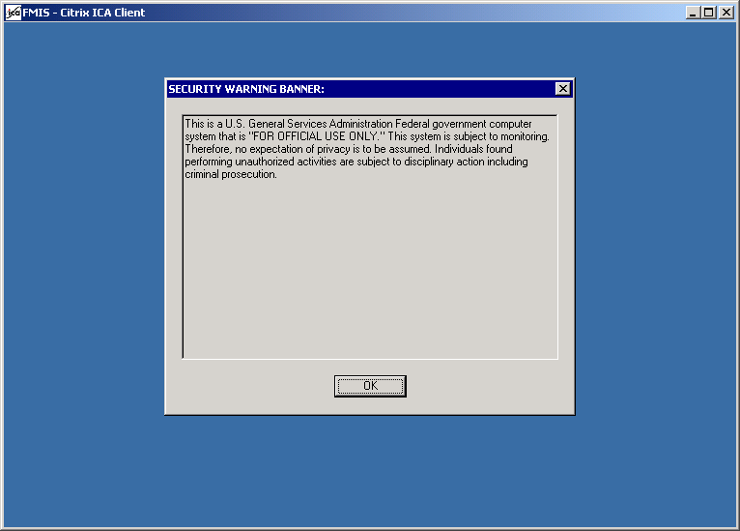
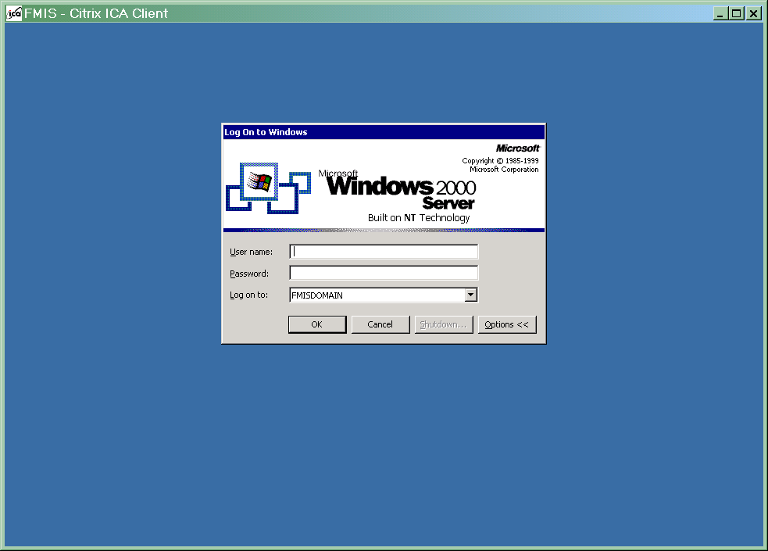

Right-click the newly created FMIS icon > Create shortcut on Desktop for users. (Delete/Replace any old FMIS shortcuts)

